CPE316 – Embedded Systems Final Project Report

[PROJECT SUBJECT]

Semester II (2021-2022)

Supervisors: Dr. Iman Elawady ; ENG. Michael B.Khani

|  |  |
| --- | --- |
| Rocinante Members | |
| * Burak, Borhan, 1810213077   [borhanburak@hotmail.com](mailto:borhanburak@hotmail.com) | * Yunus, Korkmaz, 1810213036 [yunud.korkmaz.9843@gmail.com](mailto:yunud.korkmaz.9843@gmail.com) |
| * Mert, Gül, 1810213027   [9emertgul@gmail.com](mailto:9emertgul@gmail.com) | * Mustafa, Kozan, 1810213038   [mkozan273@gmail.com](mailto:mkozan273@gmail.com) |
| * Rıfat Tayyip, Ulusoy, 1810213061   [rfatulusoy314@Outlook.com](mailto:rfatulusoy314@Outlook.com) | * Aslı, Şahin, 1810213030   [aslısahin434@gmail.com](mailto:aslısahin434@gmail.com) |

Contents

1. Introduction 3

2. Related Works 3

3. Project Design 3

3.1. Project Layout 3

3.2. Project Mechanism 4

4. Conclusion and Results 5

5. Lesson Learnt 5

6. References 5

7. Attachments 6

7.1. Project Images 6

7.2. Code Modules 7

## Introduction

Controlling humidity and temperature is a very important for many industrial sectors such as computer industry, paper manufacturing, textile, wood, wine and liquor industry. Our project is aim to solve this problem with a very cheap and compact product. Our product measure humidity and temperature and inform the user by display humidity and temperature values on an LCD display. This simple but very efficient product was completed about one month.

## Related Works

There are a lot works and product related with our topic some of them are professional products and already selling on markets

When we search on market we will see some professional product which measure humidity and temperature.

metin, saat içeren bir resim

Açıklama otomatik olarak oluşturuldusaat, siyah, cihaz, ölçü aleti içeren bir resim

Açıklama otomatik olarak oluşturuldu

Digital Thermometers Hygrometers

There are also other projects that work with arduino, esp32 or raspberry pi boards.

1.Simple Weather Station

These is very similar with our product but in this project DTH11 used as a humidity and temperature sensors. In our project we preferred DHT12 to DHT11 because DHT12 give more absolute values

metin içeren bir resim

Açıklama otomatik olarak oluşturuldu

2. Bathroom Ventilation Fan Controller

This is more complex than before project. This project also aim to measure humidity and temperature.

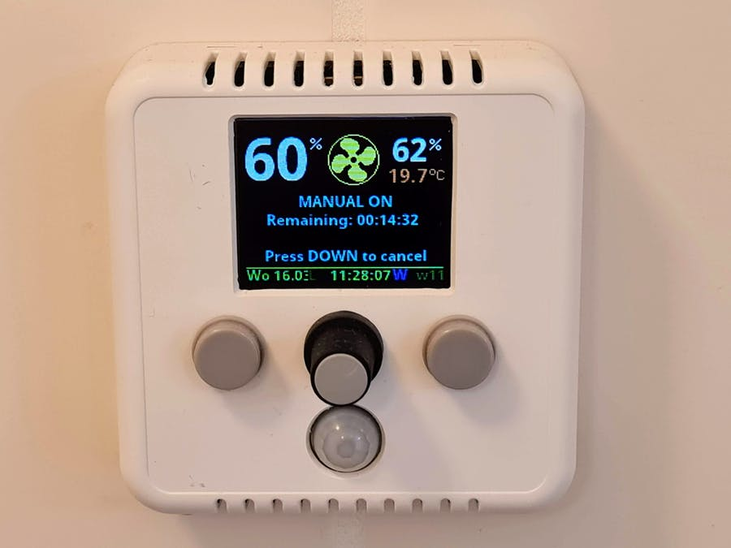

3. Arduino Sending Temperature and Humidity Data to MySQL Server

This project not only measures temperature and humidity but also records them.

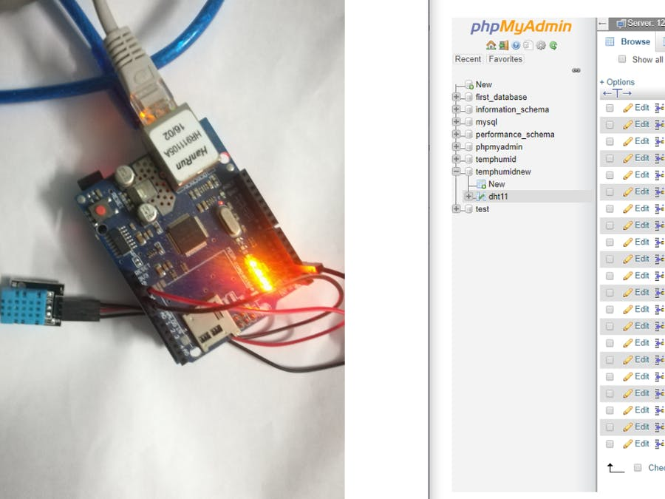

## Project Design

İn this project the problem was the bad affects of uncontrolled humidity an temperature levels. We decide to solve this problem by informing user about temperature and humidity values.

Our product mainly consists of 2 part, part one is measurement of humidity and temperature and part two is give this values to user.

Part 1: Measurement

We had to measure humidity and temperature for our project.

For measuring humidity there are three basic types of humidity sensors: capacitive, resistive and thermal. We decide to use a capacitive humidity sensor because capacitive humidity sensors offer several advantages, including very low power consumption and high output signals. Capacitive humidity sensors uses capacitive measurement, which relies on electrical capacitance. Also approximately 75% of the humidity sensors on the market today are based on the capacitive technique

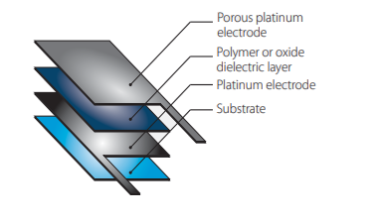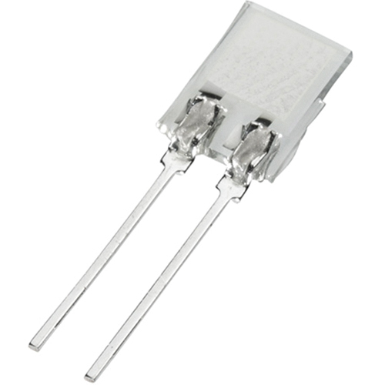

A simple Capacitive Humidity Sensor Sematic of a Capacitive Humidity Sensor

For measuring temperature commonly use four type of sensors: Negative Temperature Coefficient (NTC) thermistor, Resistance Temperature Detector (RTD) Thermocouples Semiconductor-based temperature sensors.

We use Temperature Coefficient (NTC) thermistor a thermistor is a thermally sensitive resistor that exhibits a continuous, small, incremental change in resistance correlated to variations in temperature. Thermistor is pretty enough for our project

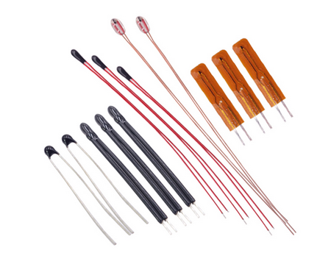

Common types of NTC thermistors

For these types of sensors we used DHT22. The DHT22 is a low-cost digital temperature and humidity sensor with a single wire digital interface. It uses a capacitive humidity sensor and a thermistor to measure the surrounding air and spits out a digital signal on the data pin. Also it is available on wokwi simulator.

metin içeren bir resim

Açıklama otomatik olarak oluşturuldu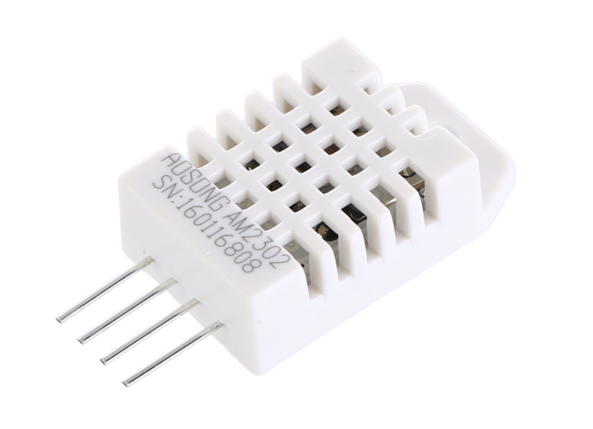

DHT22 DHT22 on WOKWİ

Part 2: Display of values

Now temperature and humidity are measured, these are need to show user. For display of values we used a 16x2 LCD module .Size of the screen can increase if need it but now it is enough for displaying two values which are humidity and temperature .

metin, saat, yeşil içeren bir resim

Açıklama otomatik olarak oluşturuldu

16x2 LCD I2C display on WOKWİ

### Project Layout

Humidity and temperature have always been a problem for waterside areas, especially for people working in industry. Our project, on the other hand, acts as a precaution for people to take precautions against these problems.

Our purpose in this project is to make an inexpensive and compact product that helps us get more control about humidity and temperature values.

Our project mainly consists of three component these are

1.DHT22

2.ESP32

3.16x2 LCD display

### Project Mechanism

Our project mechanism is simple. Temperature and humidity values measure by DHT22 sensor than process on esp32 and display on a 16x2 LCD screen



## Conclusion and Results

Finally our project is working. Basically we want to inform user about humidity and temperature values and now our product make it job pretty good . This project can improve with some additional features like alerting the user when values are too low or too high . Maybe we can increase screen size and make it more informative or we can inform user by remote notifications in later stages of the project.

## Lesson Learnt

At the beginning of project we had planed to inform user with remote notifications via telegram, but Wokwi limited us. We learned from this situation that we needed to research more about our environment and our equipment constraints before starting to project.

## References

# <https://cb-electronics.com/why-dht22-is-better-than-dht11/>

# <https://create.arduino.cc/projecthub/tarantula3/weather-station-using-arduino-and-nodemcu-d2b9d3?ref=tag&ref_id=humidity&offset=34>

# <https://create.arduino.cc/projecthub/edr1924/bathroom-ventilation-fan-controller-v2-1-ba99bc?ref=tag&ref_id=humidity&offset=9>

# <https://fm.okstate.edu/energyservices/energymanagement/blog/temp-humidity.html>

## Attachments

### Project Images

metin, cihaz, ekran görüntüsü içeren bir resim

Açıklama otomatik olarak oluşturuldu

ESP32 LCD connection schema

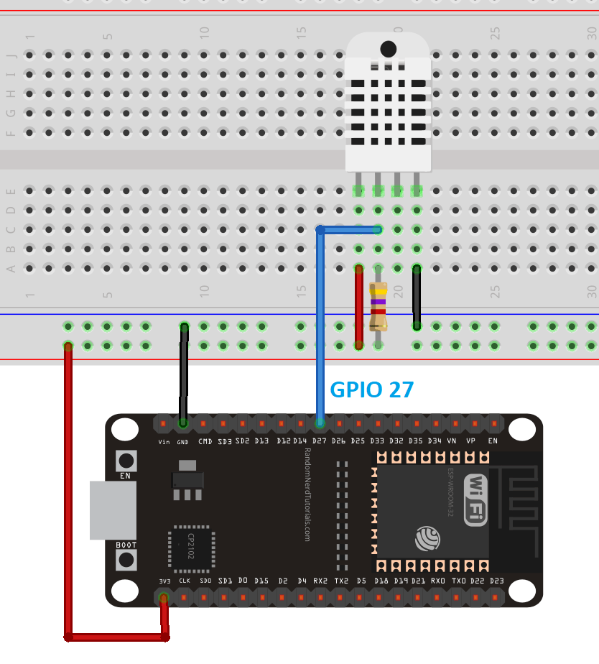

ESP32 DTH12 connection schema

### Code Modules

#### main.py

|  |  |
| --- | --- |
| 1  2  3  4  5  6  7  8  9  10  11  12  13  14  15  16  17  18  19  20  21  22  23  24  25  26  27  28  29  30  31  32  33  34  35  36  37  38  39  40  41  42  43  44  45  46 | from machine import Pin,I2C  from time import sleep,sleep_ms,ticks_ms  from i2c_lcd import I2cLcd  import dht  sensor=dht.DHT22(Pin(14))  AddressOfLcd=0x27  i2c=I2C(scl=Pin(22),sda=Pin(21),  freq=400000)  lcd=I2cLcd(i2c,AddressOfLcd,2,16)  def testLcd(temp,hum):  lcd.move_to(0,0)  lcd.putstr('Temperature:'+str(temp))  lcd.move_to(0,1)  lcd.putstr('Humidity:'+str(hum)+'%')  while True:  try:  sleep(1)  sensor.measure()  temp=sensor.temperature()  hum=sensor.humidity()  testLcd(temp,hum)  except OSError as e :  print('Failed to read sensor.') |